Lifting device calculations

The dimensions in this report base on the CAD model updated on 29 May 2017.

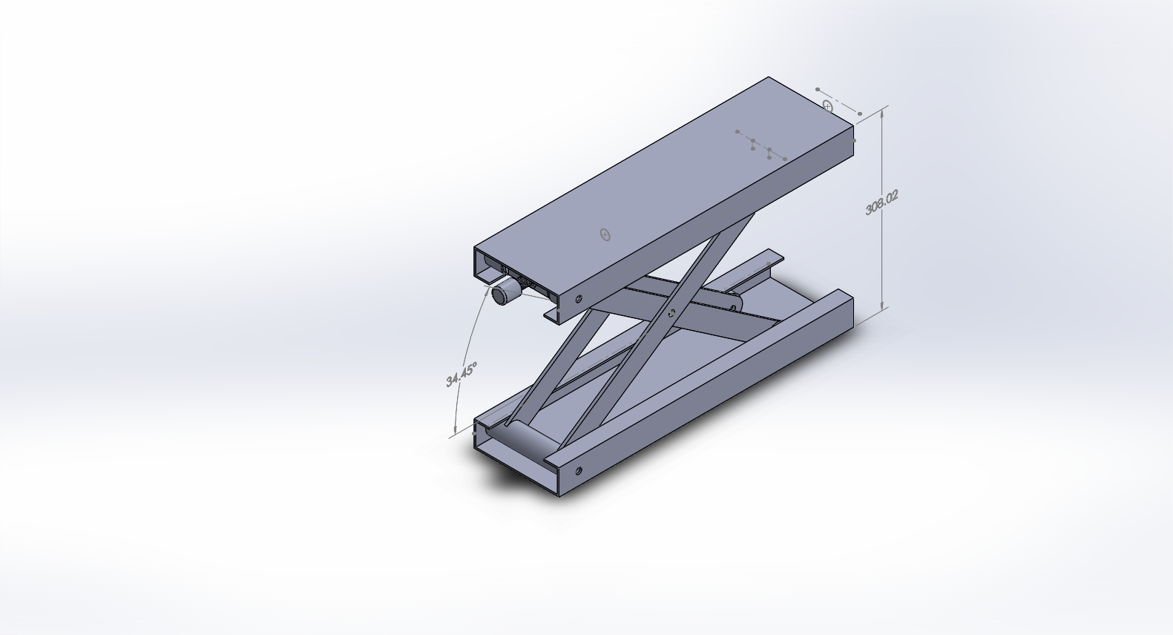

# Assumptions

Choosing lead screw SFU1 204 for initial calculations:

* Pitch diameter: 12mm
* Lead: 4mm
* Dynamic loading: 400kg
* Static loading: 670kgf

Friction coefficient between steel screw and steel balls with machine oil: 0.15

User weight (W): 1000N (~101kg)

# Calculate Linear Force Acting on Lead Nut

Rx2

Ɵ

Ɵ

W

$Rx2=\frac{w}{tan⁡(Ɵ)}$ (see appendix for step by step)

The requirement height varies from 150mm to 500mm corresponding to Ɵ from 13.28 to 78.66 degree.

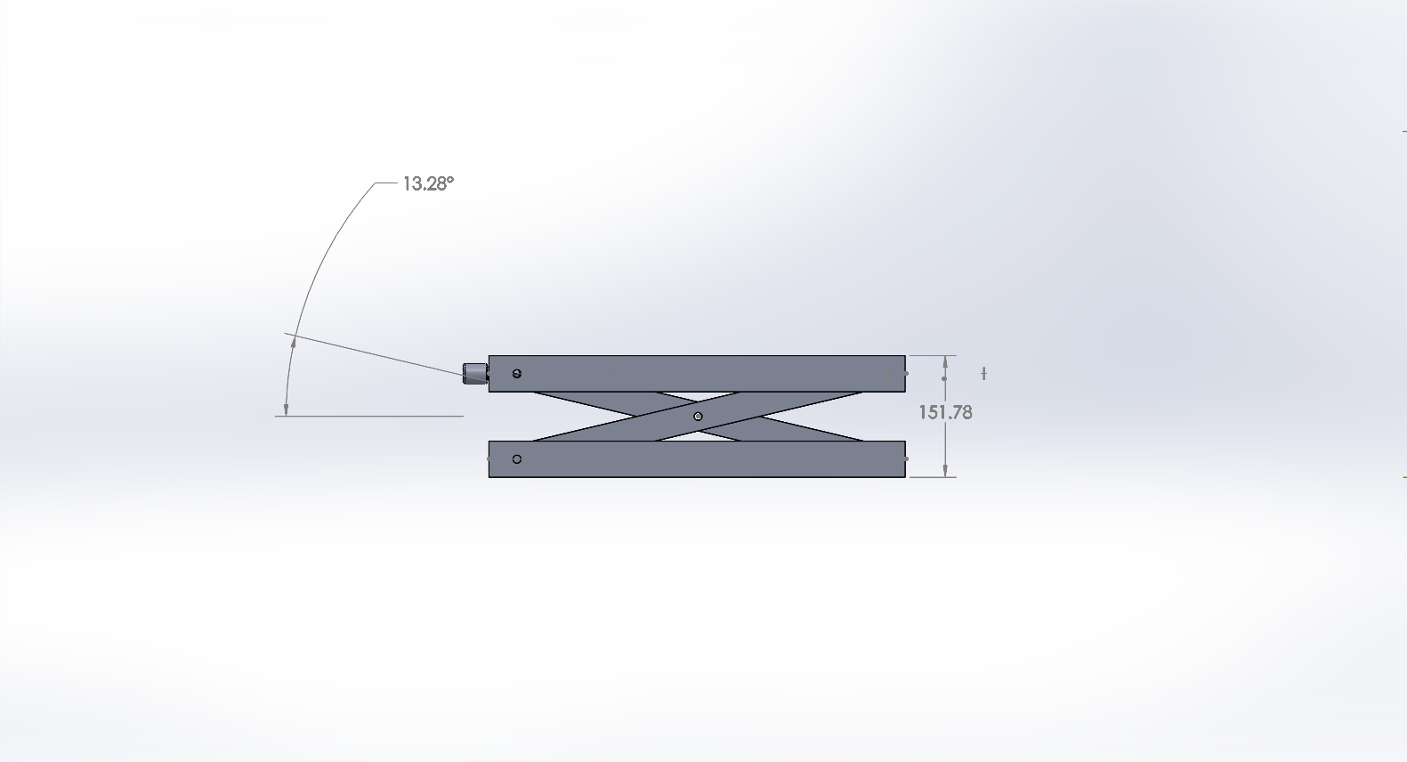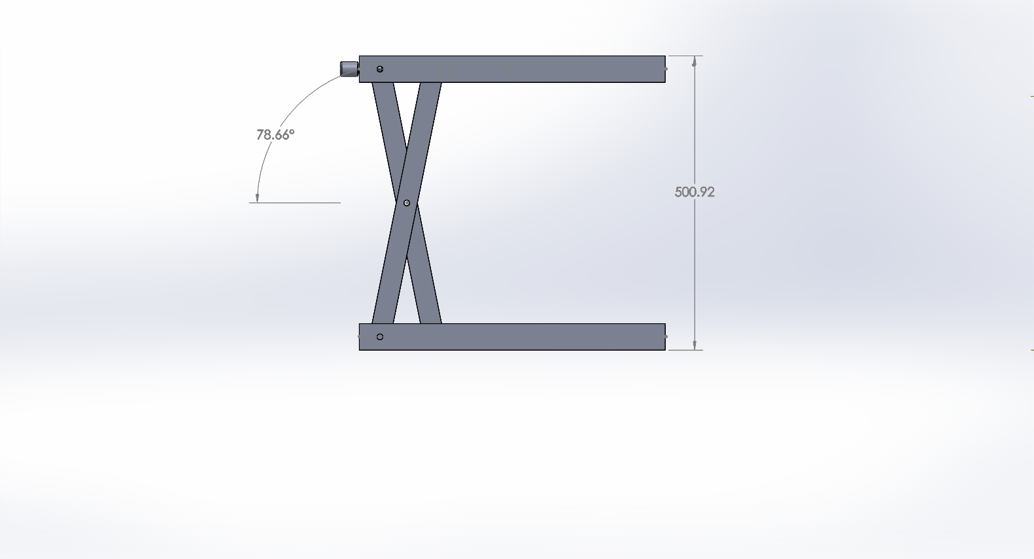

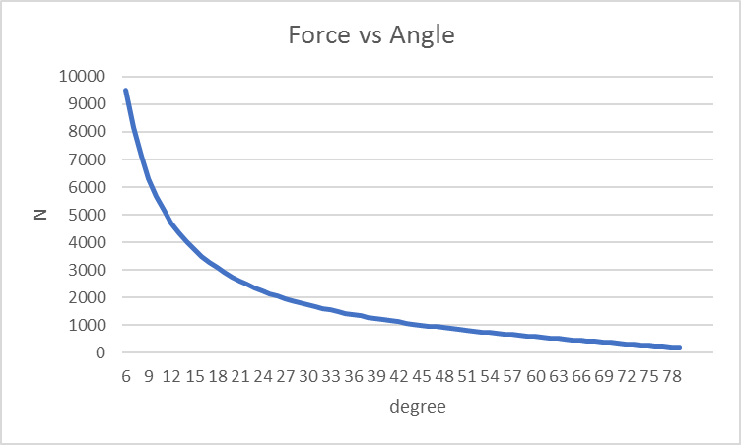

Critical force occurs when the jack is at its lowest position, Ɵ= 13.28 N= 4236 N.

# Calculate Torque Required on Lead Screw

Adopt equations for trapezoidal thread from Wiki (<https://en.wikipedia.org/wiki/Leadscrew>)

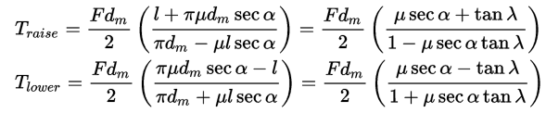

Where:

* *T* = torque
* *F* = load on the screw
* *dm* = pitch diameter
* {\displaystyle \mu \,}μ = coefficient of friction (common values are found in the adjacent table)
* *l* = lead
* {\displaystyle \phi \,}{\displaystyle \lambda \,}λ = lead angle

Maximum Torques:

Traise = 5.8 Nm

Tlower = -1.91 Nm (sign indicates opposite direction)

Assuming the handle arm (r) is 0.2m, the maximum required input is: $F=\frac{T}{r}=29 N ≈3 kg$